Regular Periodic Tessellation
# Source: AI Source: Provided by: [Data Path: Persons Table -> ID Column: 1, Name_En Column: Motasem Essam] -> From: [ChatGPT] on [7/25/2026]
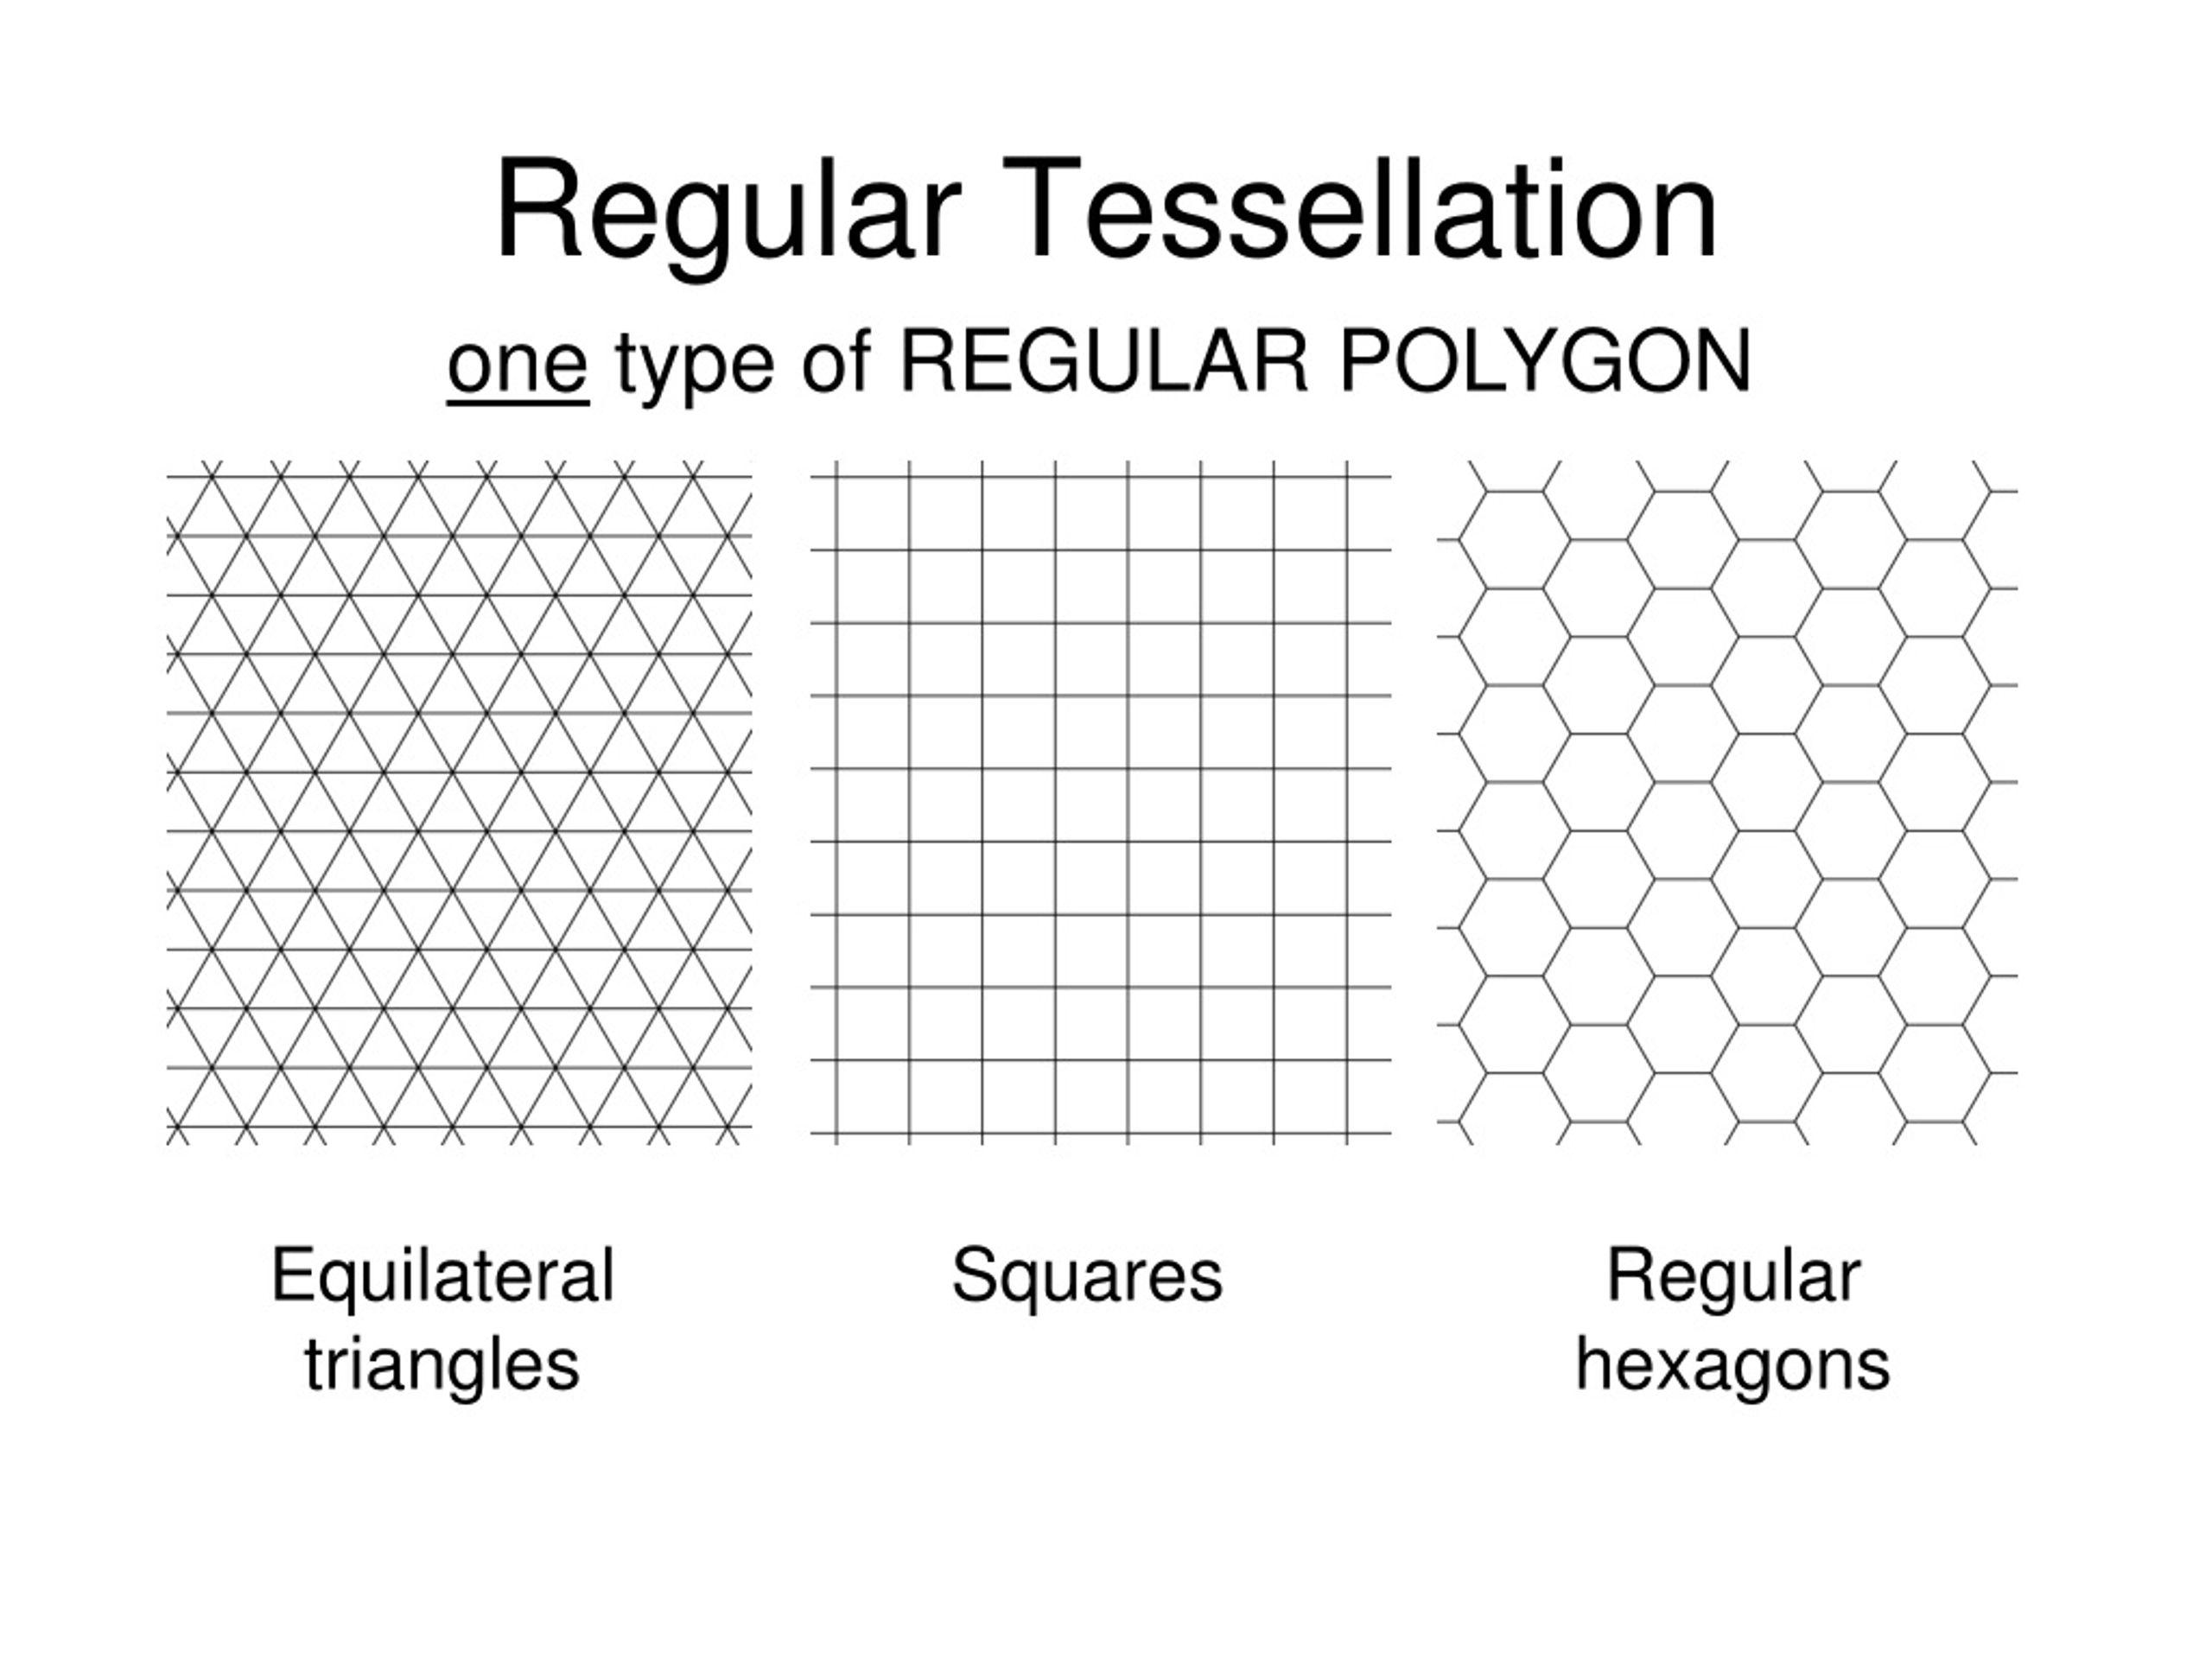
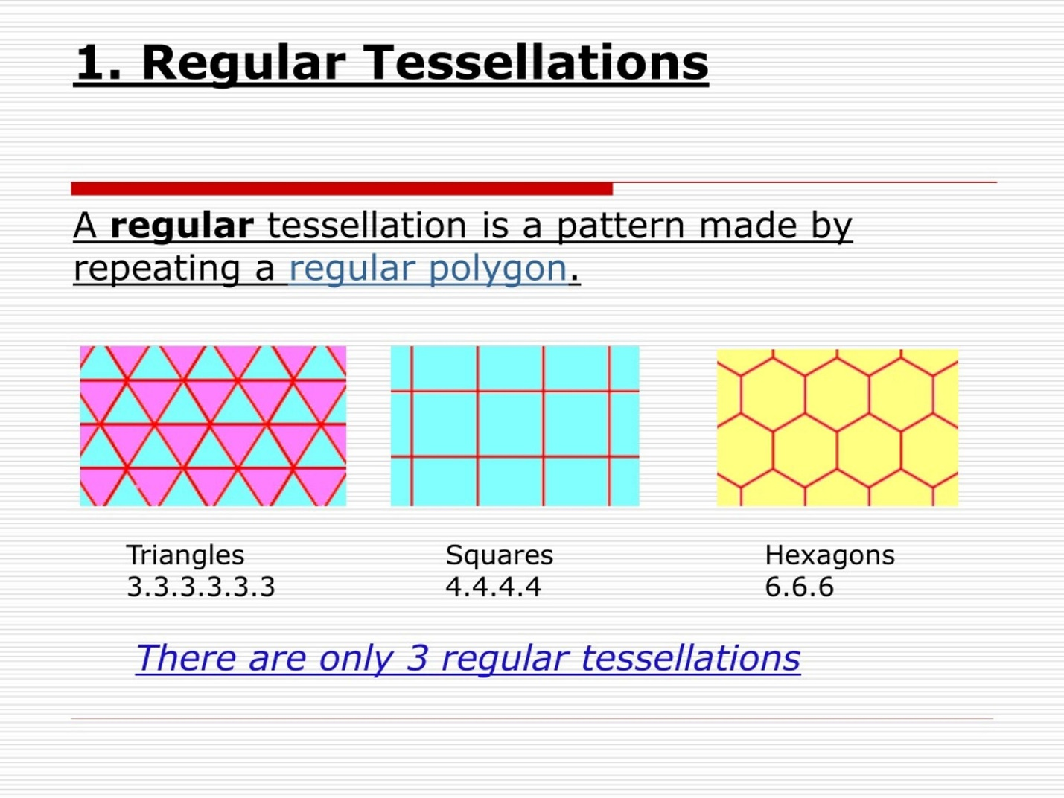
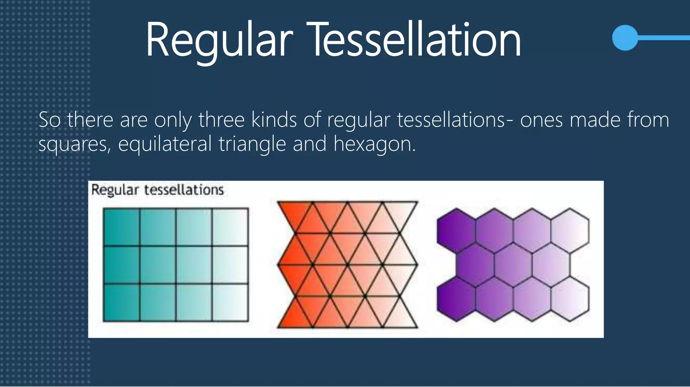
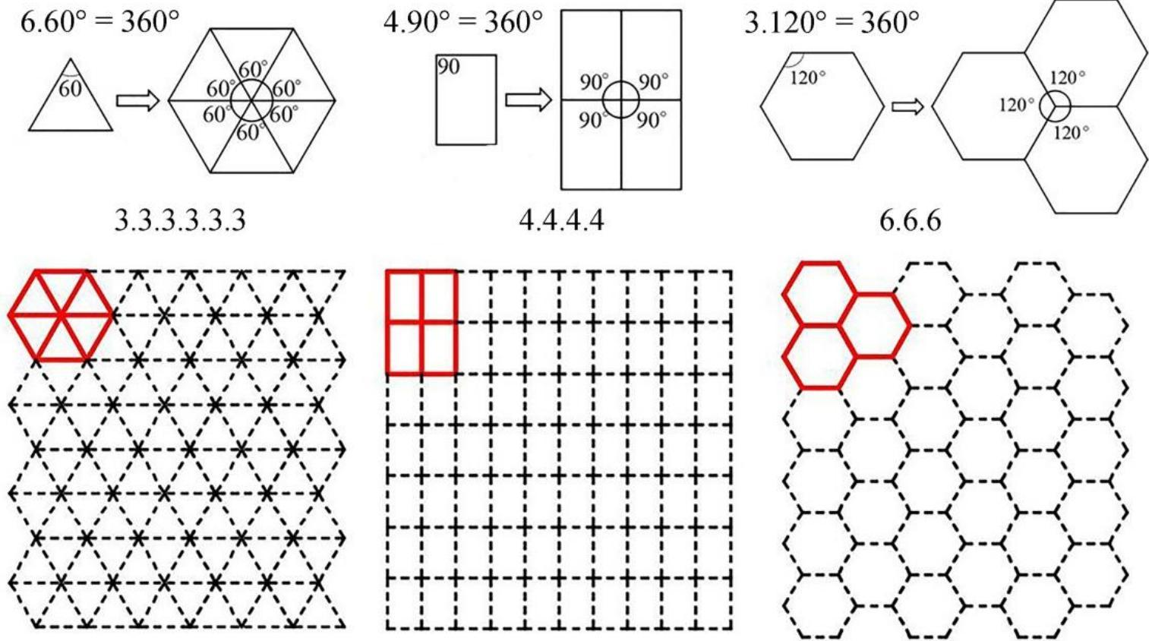

Definition
# Source: AI Source: Provided by: [Data Path: Persons Table -> ID Column: 1, Name_En Column: Motasem Essam] -> From: [ChatGPT] on [7/25/2026]
A Regular Periodic Tessellation is a tessellation of the plane that:
- Uses one type of regular polygon.
- Covers the plane completely without gaps or overlaps.
- Has a repeating pattern, meaning the tiling has translational periodicity.
- Has the same regular polygon arrangement throughout the plane.
There are exactly three regular tessellations of the Euclidean plane. They use:
- Equilateral triangles
- Squares
- Regular hexagons
(MathWorld)

The Three Regular Periodic Tessellations

1. Regular Triangular Tessellation
# Source: AI Source: Provided by: [Data Path: Persons Table -> ID Column: 1, Name_En Column: Motasem Essam] -> From: [ChatGPT] on [7/25/2026]
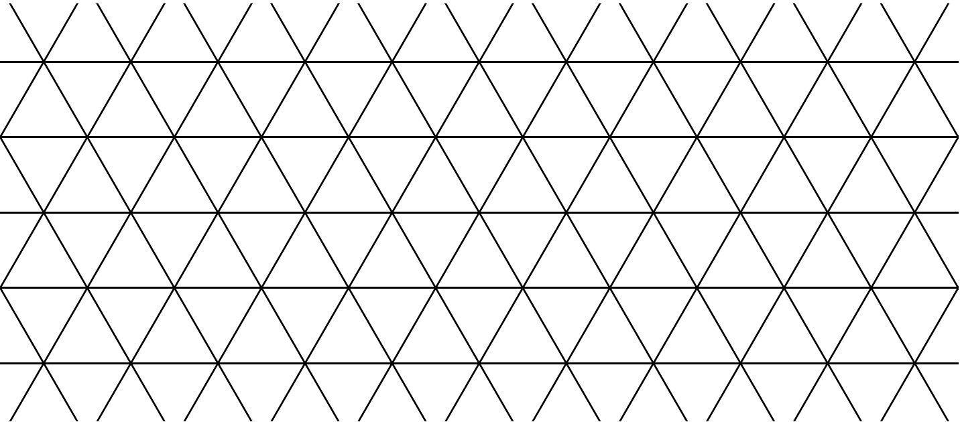
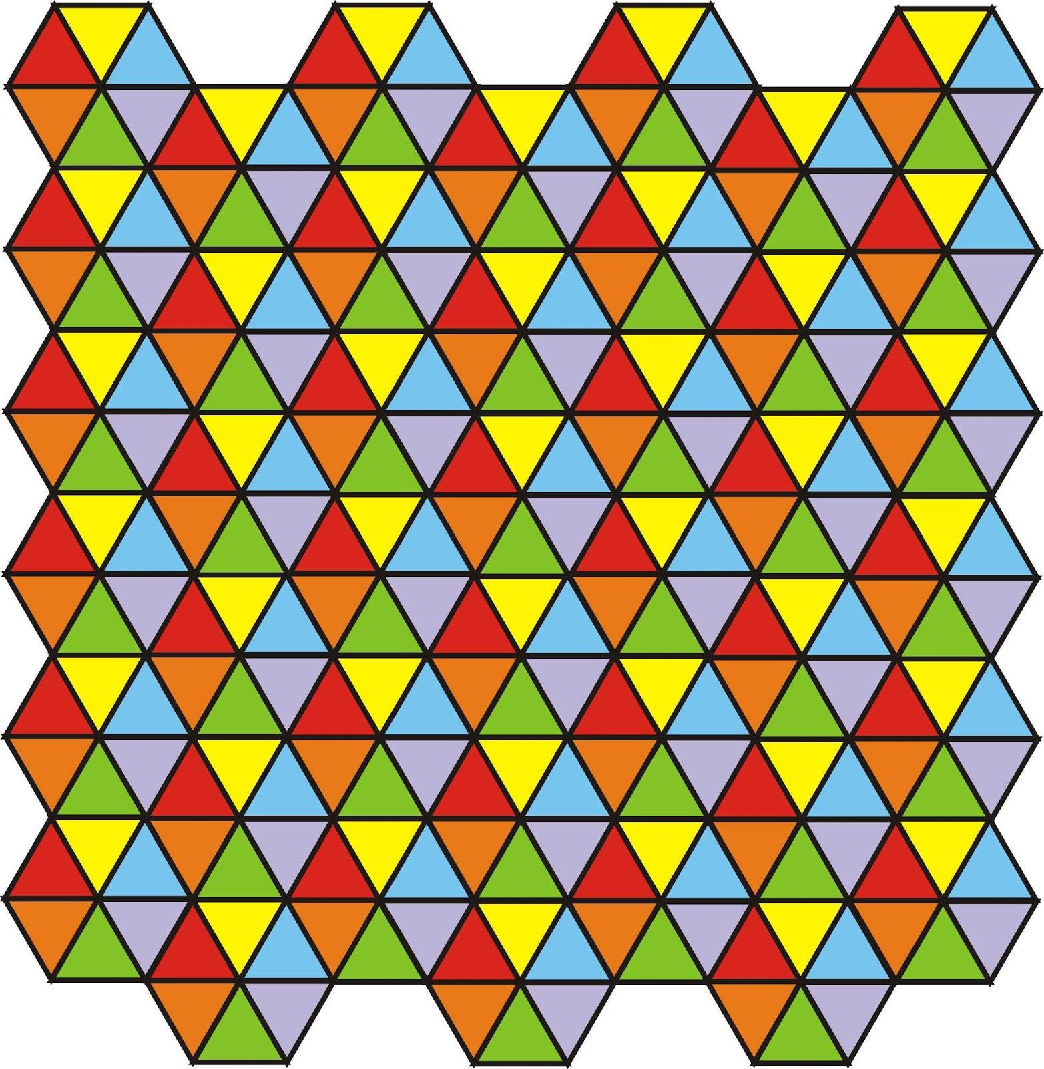
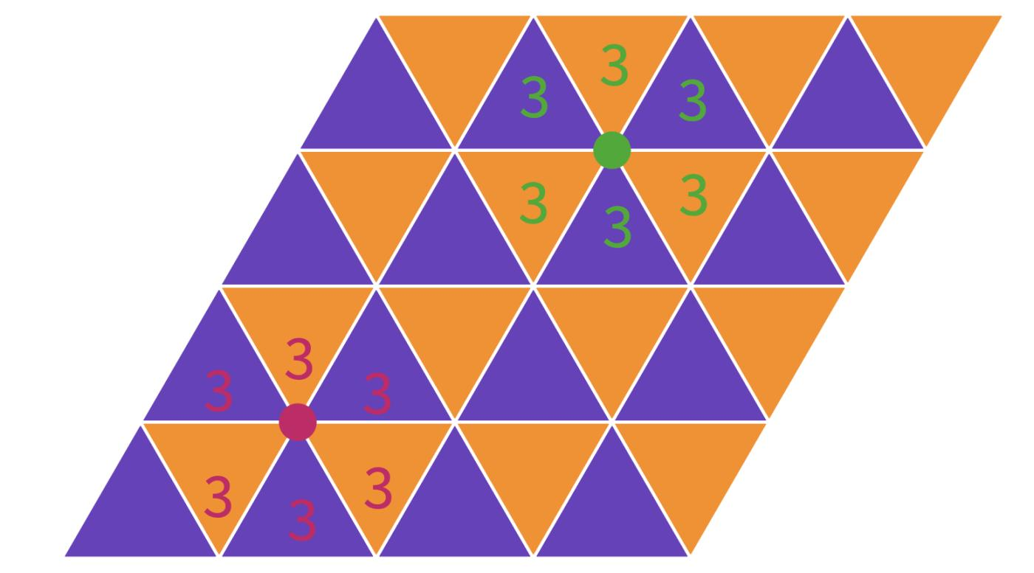
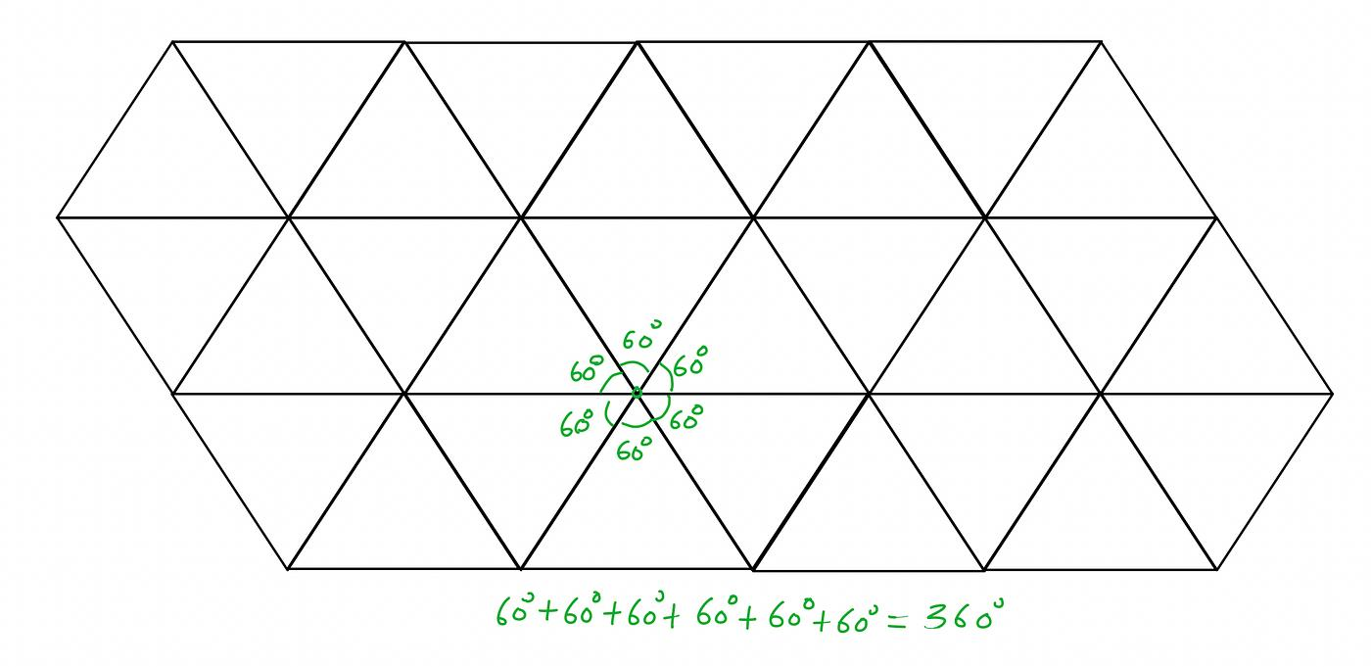
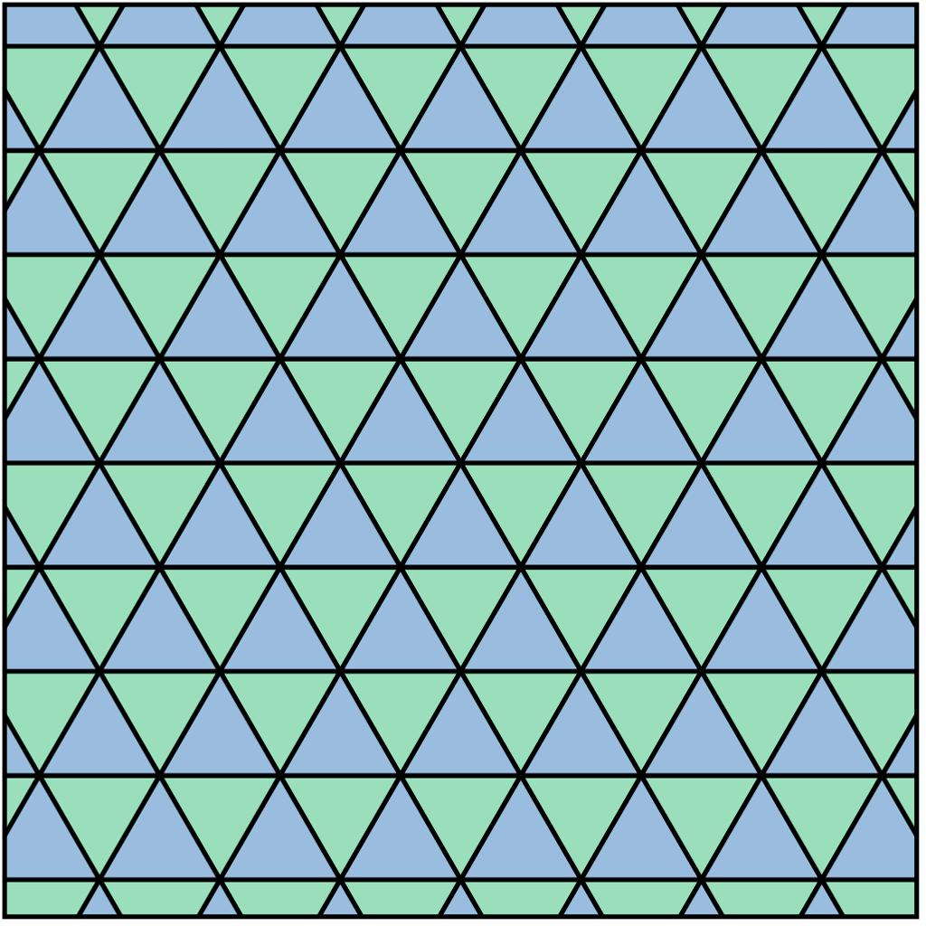
It uses only equilateral triangles.
The vertex configuration is:
$$\boxed{3.3.3.3.3.3}$$
Six triangles meet at every vertex:
$${60}^{∘}×6={360}^{∘}$$

2. Regular Square Tessellation
# Source: AI Source: Provided by: [Data Path: Persons Table -> ID Column: 1, Name_En Column: Motasem Essam] -> From: [ChatGPT] on [7/25/2026]
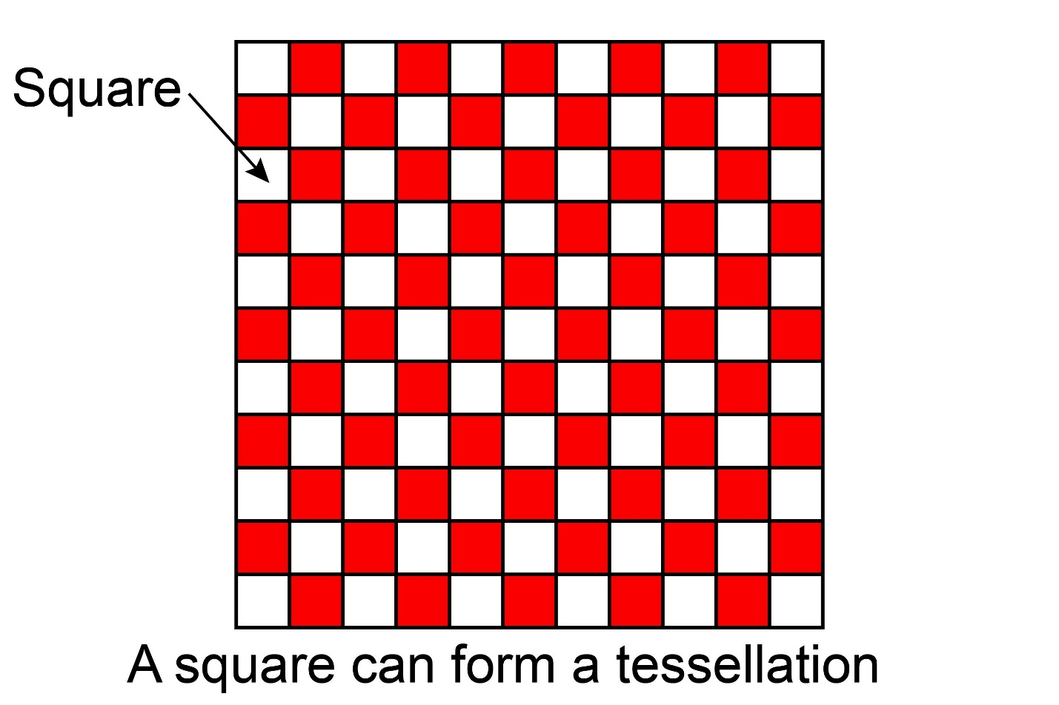
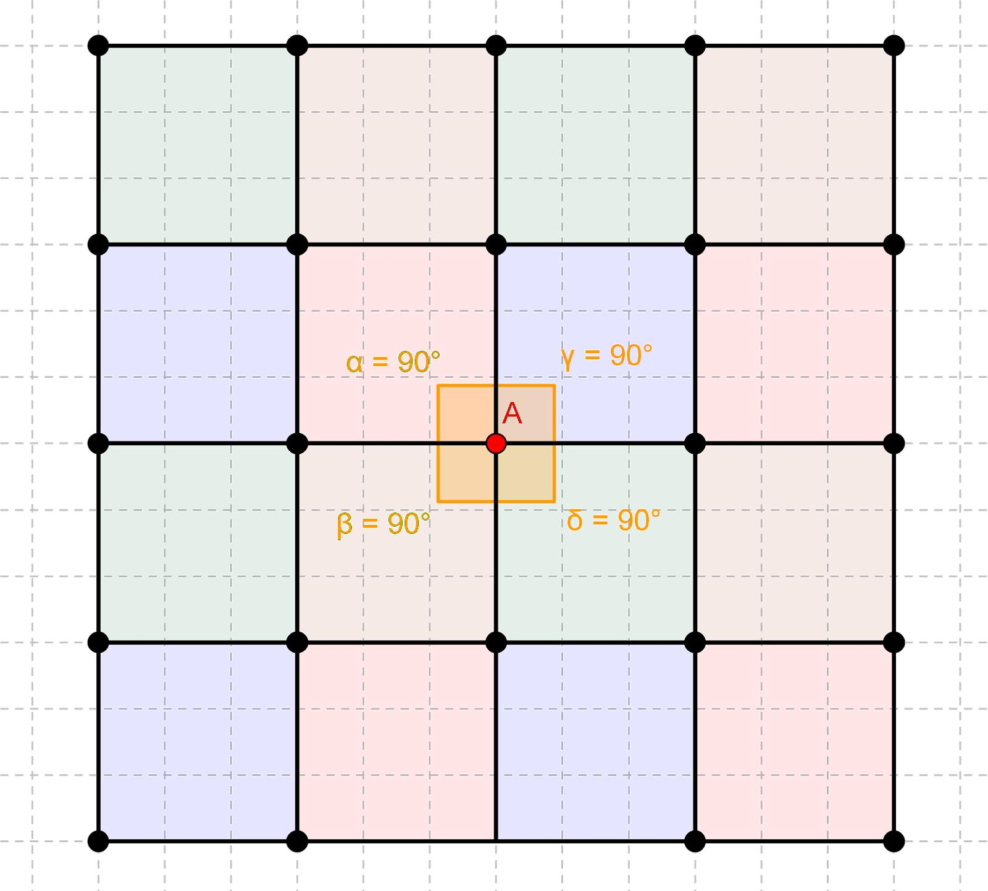
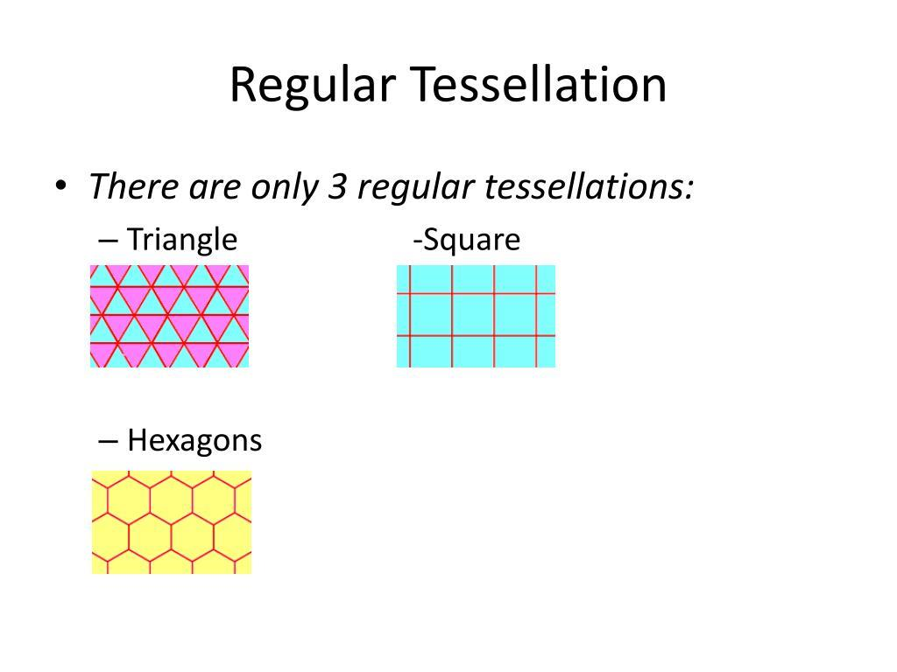
It uses only squares.
The vertex configuration is:
$$\boxed{4.4.4.4}$$
Four squares meet at every vertex:
$${90}^{∘}×4={360}^{∘}$$

3. Regular Hexagonal Tessellation
# Source: AI Source: Provided by: [Data Path: Persons Table -> ID Column: 1, Name_En Column: Motasem Essam] -> From: [ChatGPT] on [7/25/2026]
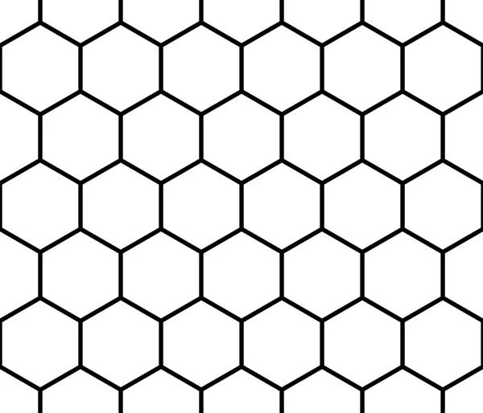
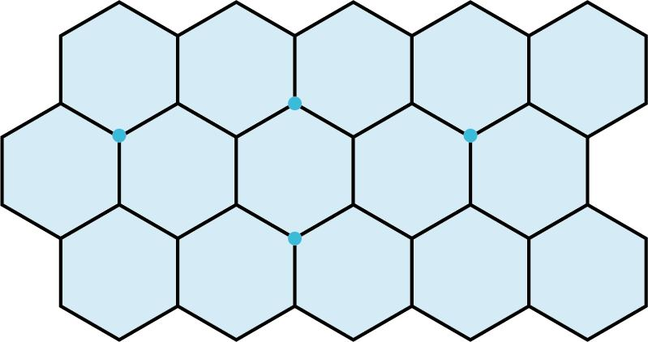
It uses only regular hexagons.
The vertex configuration is:
$$\boxed{6.6.6}$$
Three hexagons meet at every vertex:
$${120}^{∘}×3={360}^{∘}$$
These three are the only regular tessellations in the Euclidean plane. (MathWorld)

Why Are They Periodic?
# Source: AI Source: Provided by: [Data Path: Persons Table -> ID Column: 1, Name_En Column: Motasem Essam] -> From: [ChatGPT] on [7/25/2026]
A tessellation is periodic when its entire pattern repeats under a nonzero translation.
In simpler terms, you can shift the pattern by a certain distance and direction and obtain exactly the same arrangement.
For example, in a square tessellation:

□ □ □ □ □
□ □ □ □ □
□ □ □ □ □
□ □ □ □ □
Moving the pattern by one square horizontally or vertically reproduces the same arrangement.
Thus:
$$\boxed{\text{Regular}+\text{Repeating}=\text{Regular Periodic}}$$

Why Only Three?
# Source: AI Source: Provided by: [Data Path: Persons Table -> ID Column: 1, Name_En Column: Motasem Essam] -> From: [ChatGPT] on [7/25/2026]
For a regular $n$-gon, the interior angle is:
$$\frac{\left(n-2\right){180}^{∘}}{n}$$
For a regular tessellation, an integer number $q$of identical regular polygons must meet at every vertex and satisfy:
$$q\left(\frac{\left(n-2\right){180}^{∘}}{n}\right)={360}^{∘}$$
This leads to:
$$\frac{1}{n}+\frac{1}{q}=\frac{1}{2}$$
The only Euclidean solutions are:
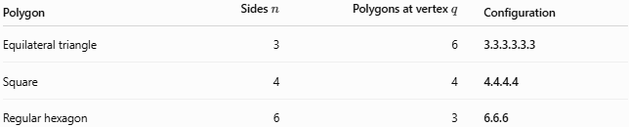
Polygon | Sides $n$ | Polygons at vertex $q$ | Configuration
Equilateral triangle | 3 | 6 | 3.3.3.3.3.3
Square | 4 | 4 | 4.4.4.4
Regular hexagon | 6 | 3 | 6.6.6
Therefore:
$$\boxed{3, 4, 6}$$
are the only possible regular polygon side counts for a regular tessellation of the Euclidean plane. (MathWorld)

Classification
# Source: AI Source: Provided by: [Data Path: Persons Table -> ID Column: 1, Name_En Column: Motasem Essam] -> From: [ChatGPT] on [7/25/2026]
For your knowledge-base hierarchy:
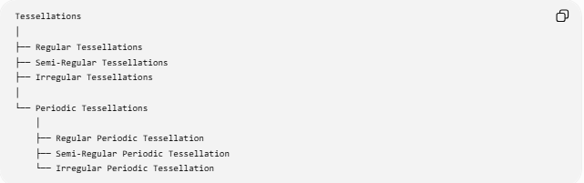
Tessellations
│
├── Regular Tessellations
├── Semi-Regular Tessellations
├── Irregular Tessellations
│
└── Periodic Tessellations
│
├── Regular Periodic Tessellation
├── Semi-Regular Periodic Tessellation
└── Irregular Periodic Tessellation
However, there is an important point:
Regular/Semi-Regular/Irregular and Periodic/Non-Periodic are different classification dimensions.
For example, a regular tessellation is automatically periodic, while an irregular tessellation can be either periodic or non-periodic.

Properties
# Source: AI Source: Provided by: [Data Path: Persons Table -> ID Column: 1, Name_En Column: Motasem Essam] -> From: [ChatGPT] on [7/25/2026]
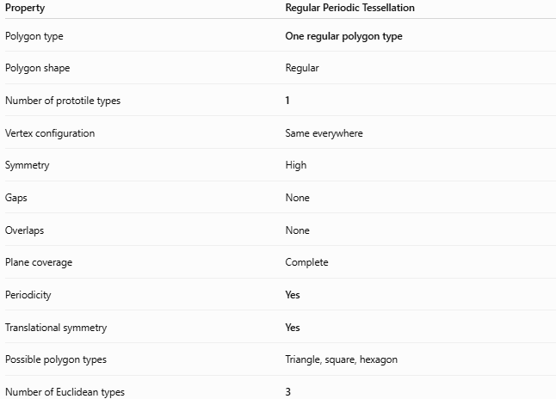
Property | Regular Periodic Tessellation
Polygon type | One regular polygon type
Polygon shape | Regular
Number of prototile types | 1
Vertex configuration | Same everywhere
Symmetry | High
Gaps | None
Overlaps | None
Plane coverage | Complete
Periodicity | Yes
Translational symmetry | Yes
Possible polygon types | Triangle, square, hexagon
Number of Euclidean types | 3

Regular Periodic vs Semi-Regular Periodic
# Source: AI Source: Provided by: [Data Path: Persons Table -> ID Column: 1, Name_En Column: Motasem Essam] -> From: [ChatGPT] on [7/25/2026]
This distinction is important for your classification.
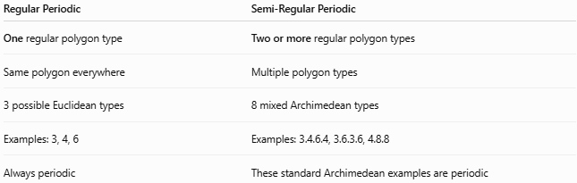
Regular Periodic | Semi-Regular Periodic
One regular polygon type | Two or more regular polygon types
Same polygon everywhere | Multiple polygon types
3 possible Euclidean types | 8 mixed Archimedean types
Examples: 3, 4, 6 | Examples: 3.4.6.4, 3.6.3.6, 4.8.8
Always periodic | These standard Archimedean examples are periodic
The semi-regular tessellations use two or more convex regular polygons while maintaining the same polygon sequence around every vertex. (MathWorld)

Regular Periodic vs Irregular Periodic
# Source: AI Source: Provided by: [Data Path: Persons Table -> ID Column: 1, Name_En Column: Motasem Essam] -> From: [ChatGPT] on [7/25/2026]
These are also different:
Regular Periodic
$$\boxed{\text{Regular Polygon}+\text{Periodic Pattern}}$$
Example:
$$\boxed{4.4.4.4}$$
Irregular Periodic
$$\boxed{\text{Irregular Polygon/Arrangement}+\text{Periodic Pattern}}$$
An irregular tessellation can still repeat periodically. Therefore, irregular does not mean non-periodic.

Examples
# Source: AI Source: Provided by: [Data Path: Persons Table -> ID Column: 1, Name_En Column: Motasem Essam] -> From: [ChatGPT] on [7/25/2026]
Triangular
$$\boxed{3.3.3.3.3.3}$$
Six equilateral triangles around each vertex.
Square
$$\boxed{4.4.4.4}$$
Four squares around each vertex.
Hexagonal
$$\boxed{6.6.6}$$
Three regular hexagons around each vertex.
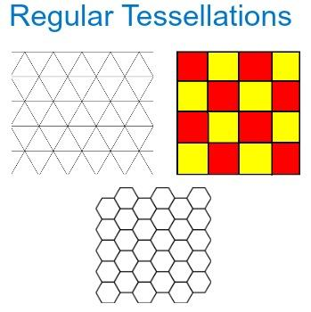
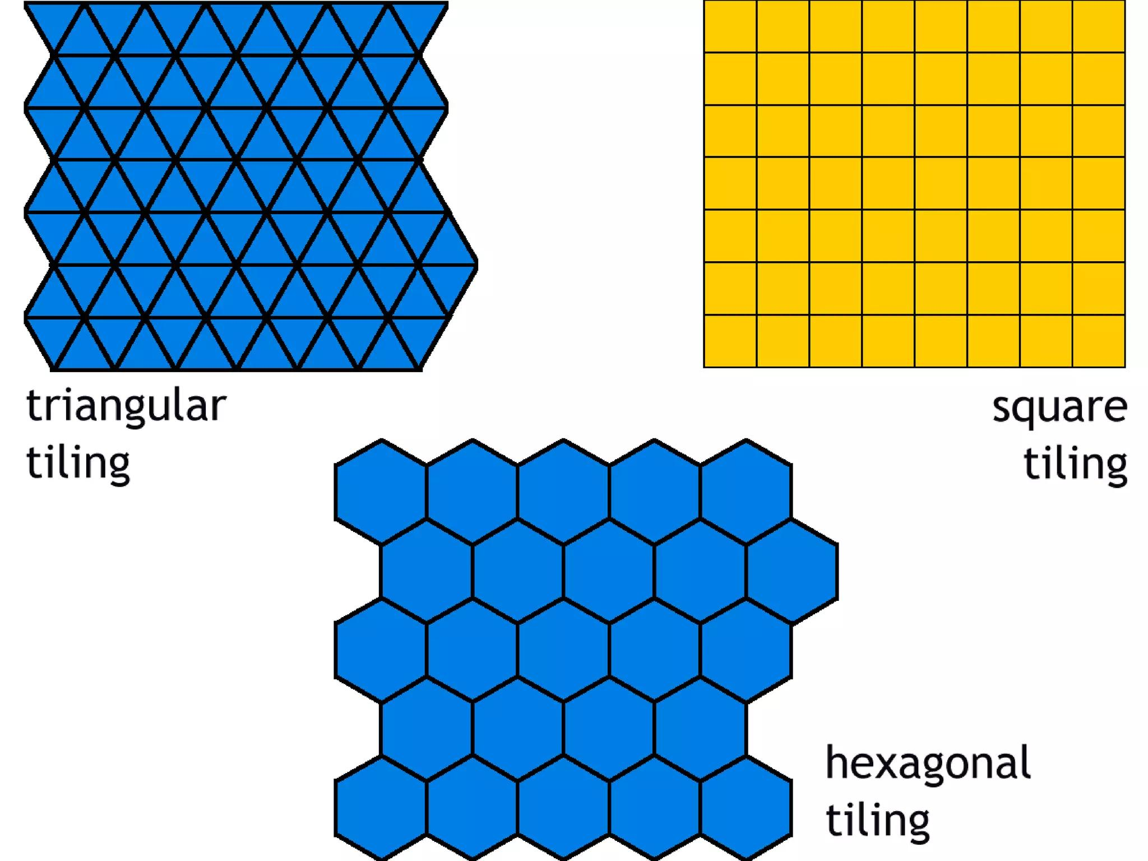
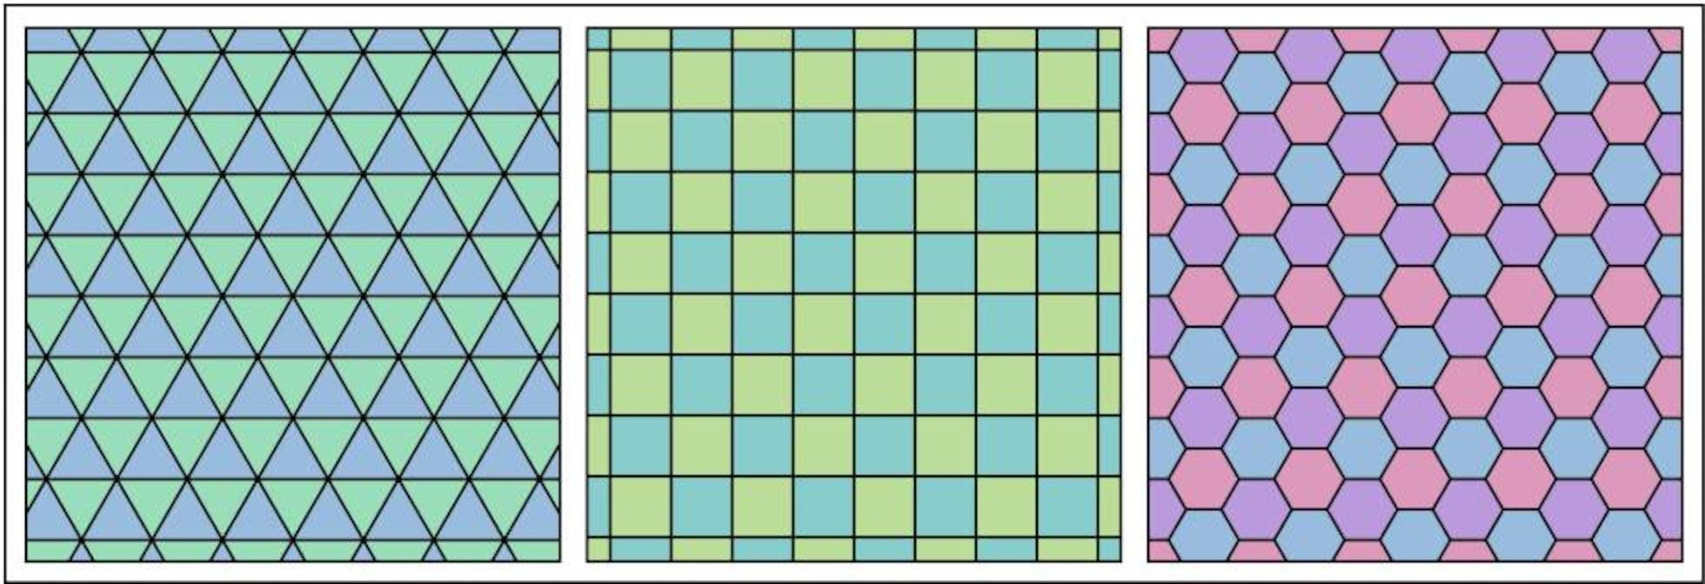

Key Points
# Source: AI Source: Provided by: [Data Path: Persons Table -> ID Column: 1, Name_En Column: Motasem Essam] -> From: [ChatGPT] on [7/25/2026]
- A Regular Periodic Tessellation uses one type of regular polygon.
- It covers the plane without gaps or overlaps.
- Its pattern repeats periodically.
- It has translational symmetry.
- The same vertex configuration occurs throughout the tessellation.
- There are exactly three regular Euclidean tessellations.
- They are:
  - 3.3.3.3.3.3 — equilateral triangles
  - 4.4.4.4 — squares
  - 6.6.6 — regular hexagons
- The classification Periodic describes repetition, while Regular describes the polygon type and uniformity.
- Therefore, Regular and Periodic are related but conceptually distinct properties.

Conclusion
# Source: AI Source: Provided by: [Data Path: Persons Table -> ID Column: 1, Name_En Column: Motasem Essam] -> From: [ChatGPT] on [7/25/2026]
$$\boxed{\text{Regular Periodic Tessellation}=\text{one regular polygon type arranged in a repeating plane-filling pattern}}$$
The complete set is:
$$\boxed{\begin{aligned}3.3.3.3.3.3&→\text{Equilateral Triangles} \\ 4.4.4.4&→\text{Squares} \\ 6.6.6&→\text{Regular Hexagons}\end{aligned}}$$
These are the only three regular tessellations of the Euclidean plane. (MathWorld)

